Stacks
Y13 - Cambridge International 9618 | Data Structures | Student booklet
Name: _______________________________ | Date: _____________

This booklet has everything you need for the lesson in one place. Work through it in order:
- Learn sections show the key slides. Read them carefully - they explain the ideas and show worked examples.
- Task sections are where you practise. Each task uses what the slides just before it taught you.
- Tasks get harder as you go, and are written like real Cambridge 9618 Paper 4 questions. Task 6 is done at the computer.
Task 1 Retrieval check [5 marks]
Circle True or False for each statement. If a statement is false, write a short correction.
Statement | True | False | Correction if false
A stack follows Last In First Out (LIFO).
Push adds a new item to the bottom of the stack.
Pop removes the item that was added most recently.
If StackPointer holds the next free space and equals 0, the stack is empty.
Like a queue, a stack needs a head pointer and a tail pointer.

Learn What is a stack?
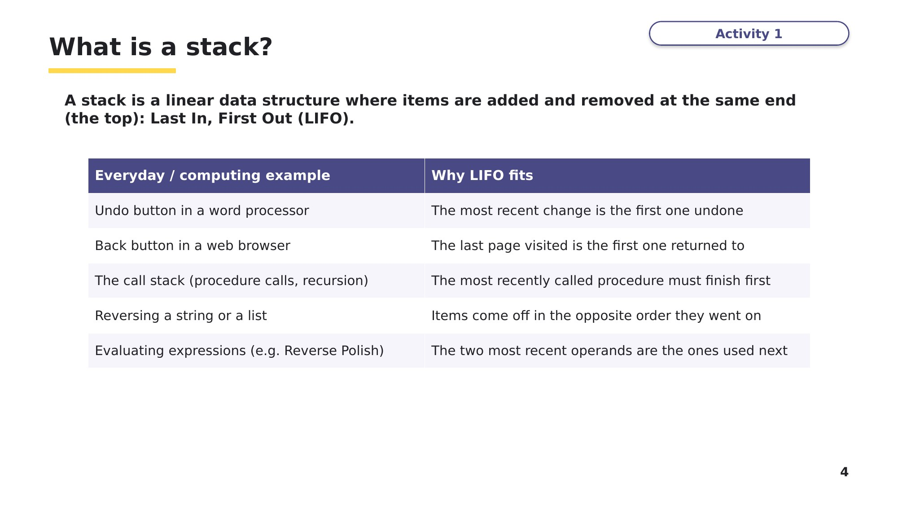
Slide 4 - What is a stack?
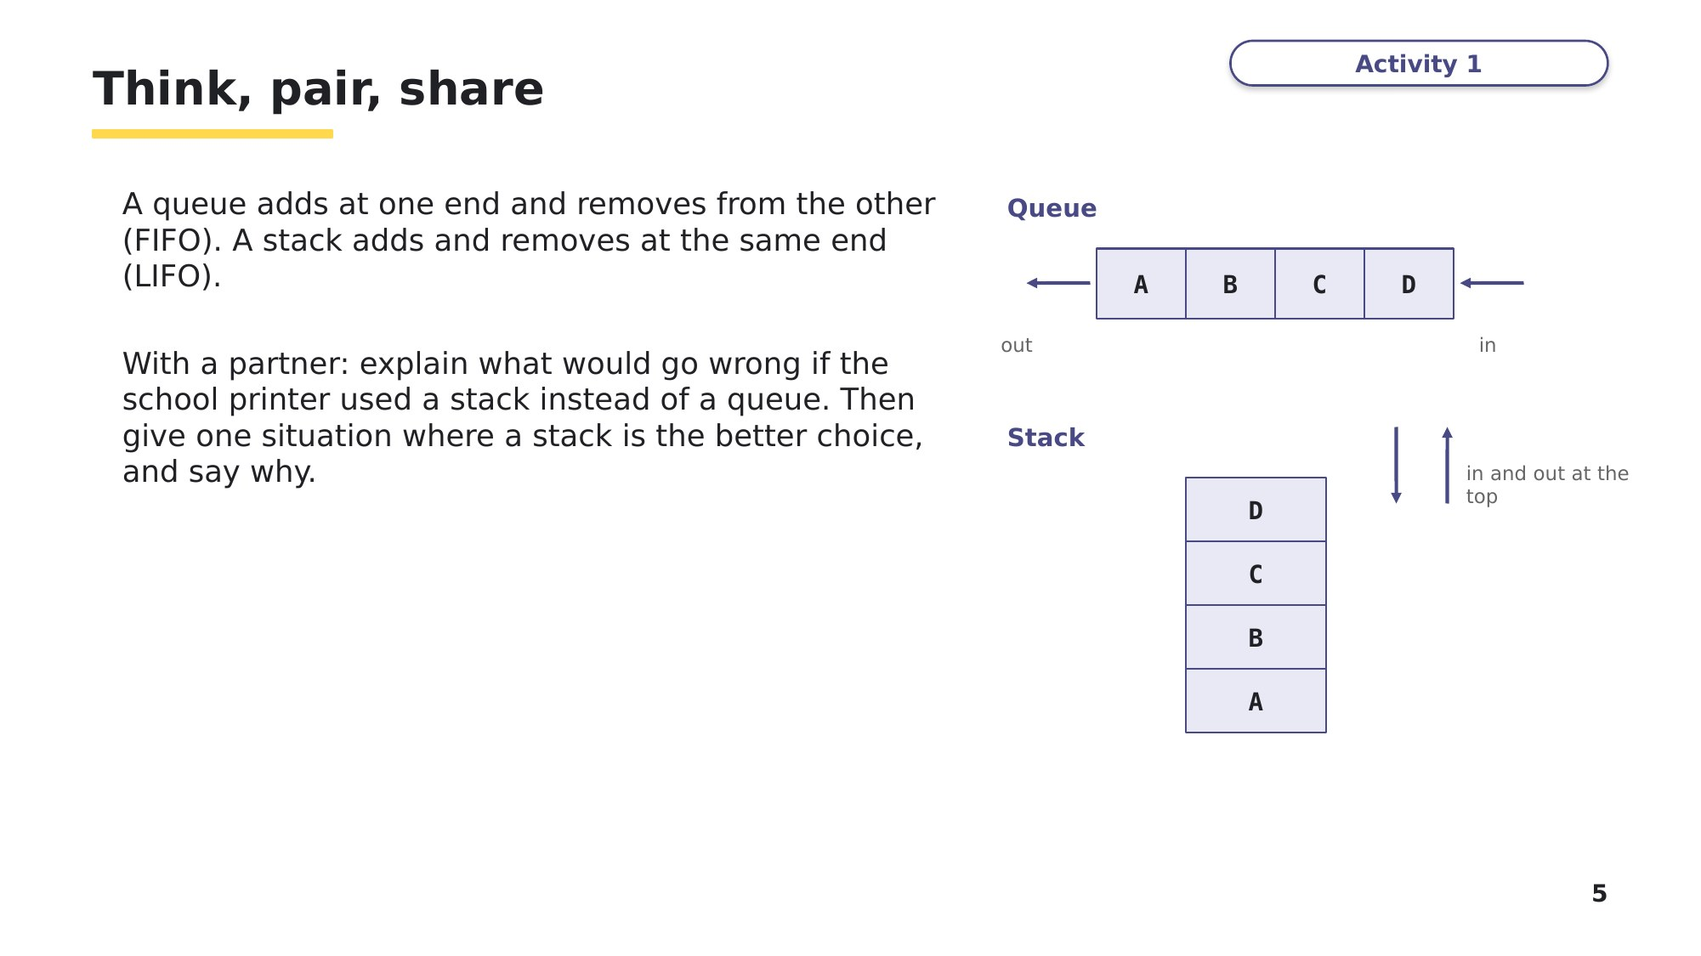
Slide 5 - Think, pair, share
Your answer to the think, pair, share question:
Learn Storing a stack in an array
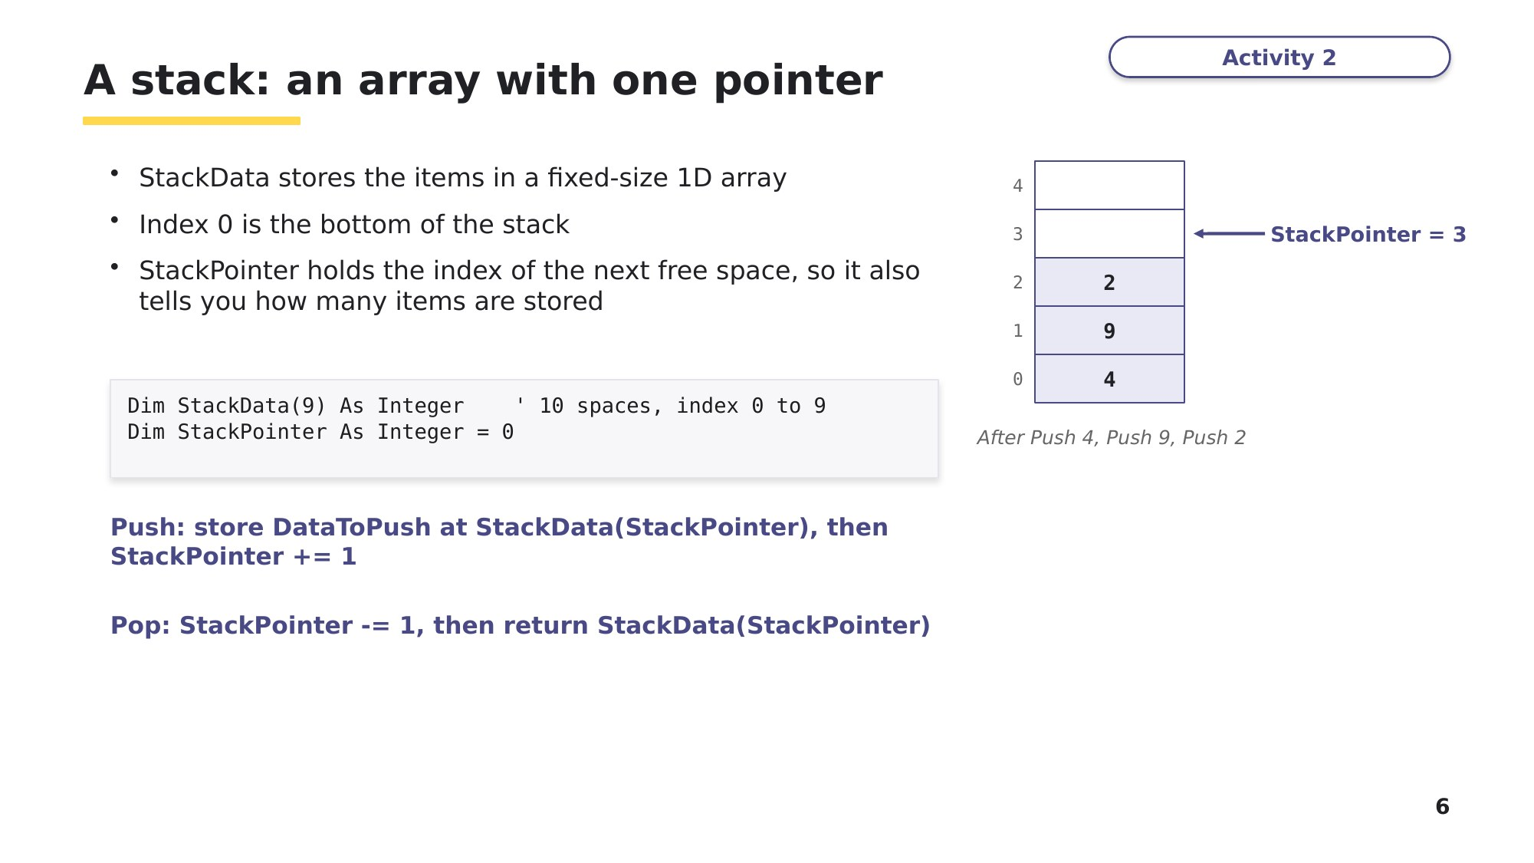
Slide 6 - A stack: an array with one pointer
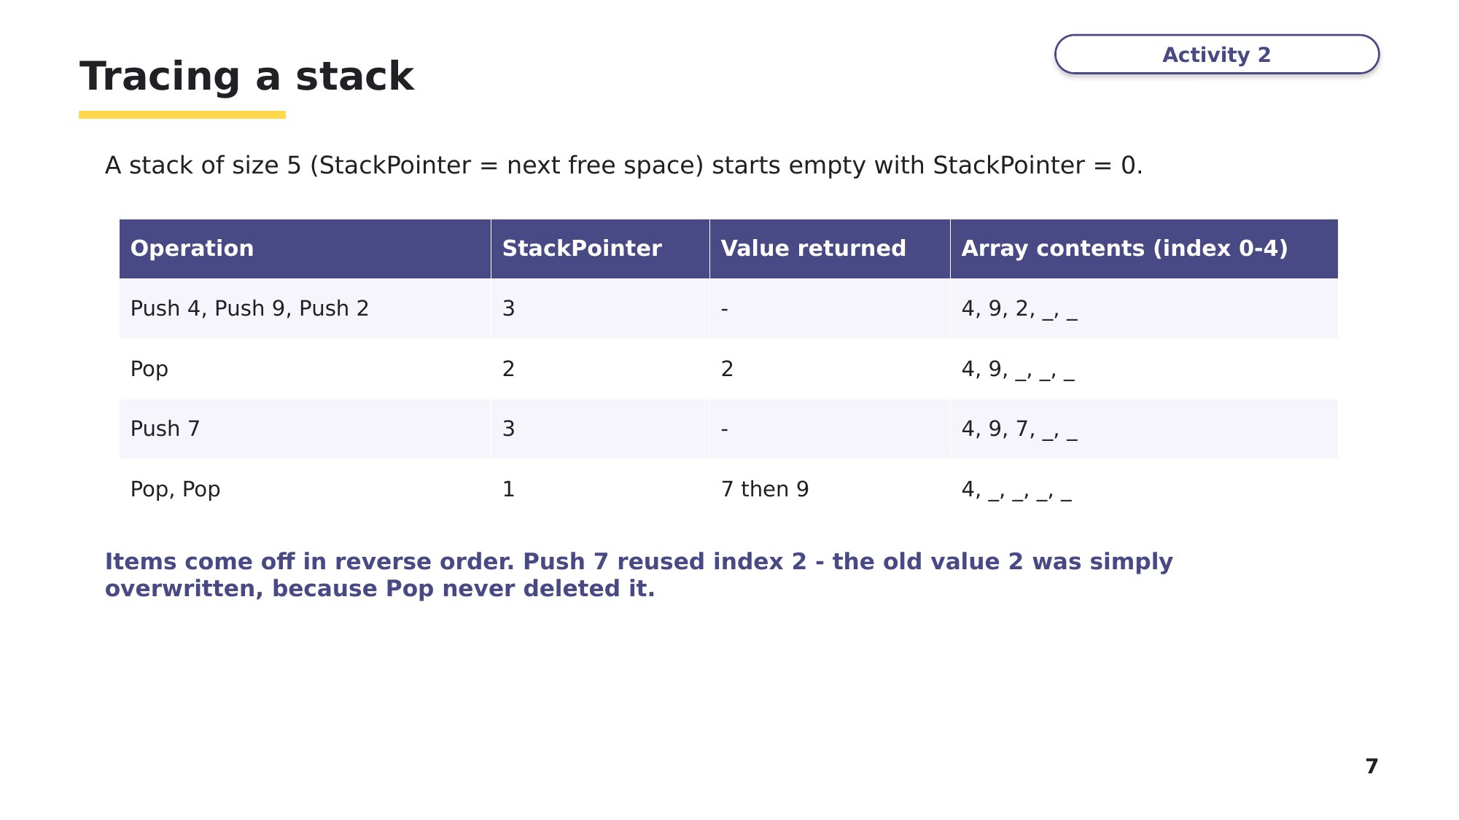
Slide 7 - Tracing a stack
Task 2 Tracing a stack [6 marks]
A stack is implemented as an array StackData of size 5 (indices 0 to 4). StackPointer stores the index of the next free space and starts at 0. Push() returns False if the stack is full. Pop() returns -1 if the stack is empty.
Part A - Complete the table as these operations are carried out in order: Push(15), Push(8), Push(23), Pop(), Push(4), Push(16), Push(42), Push(7), Pop(). Use _ for a space that is not part of the stack. [4]
Operation | StackPointer | Value returned | Array contents (index 0-4)
Push(15), Push(8), Push(23)
Pop()
Push(4), Push(16), Push(42)
Push(7)
Pop()

Learn Full, empty and the two pointer conventions
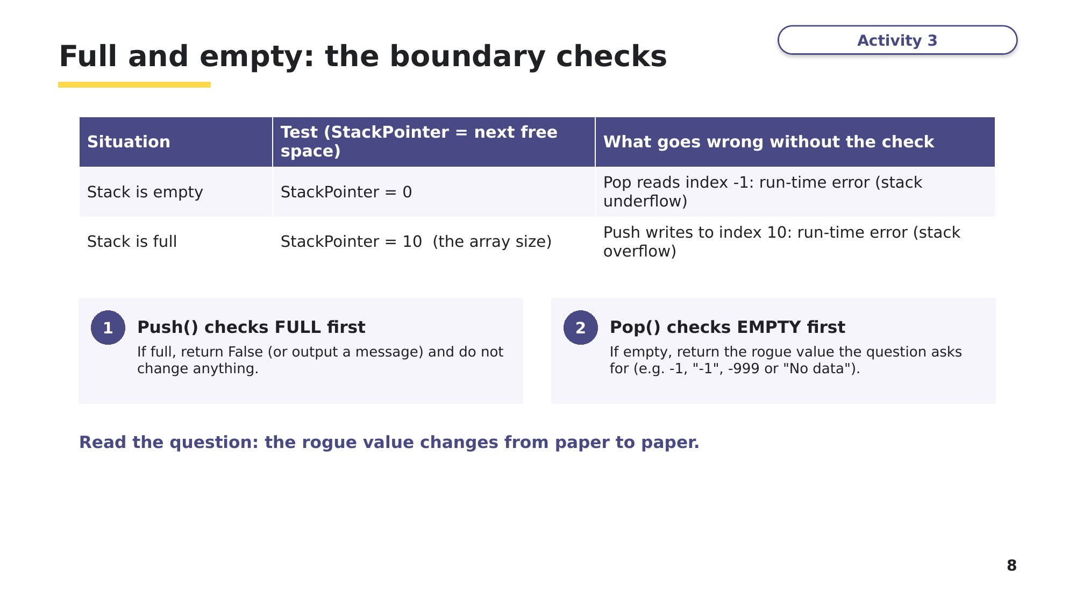
Slide 8 - Full and empty: the boundary checks
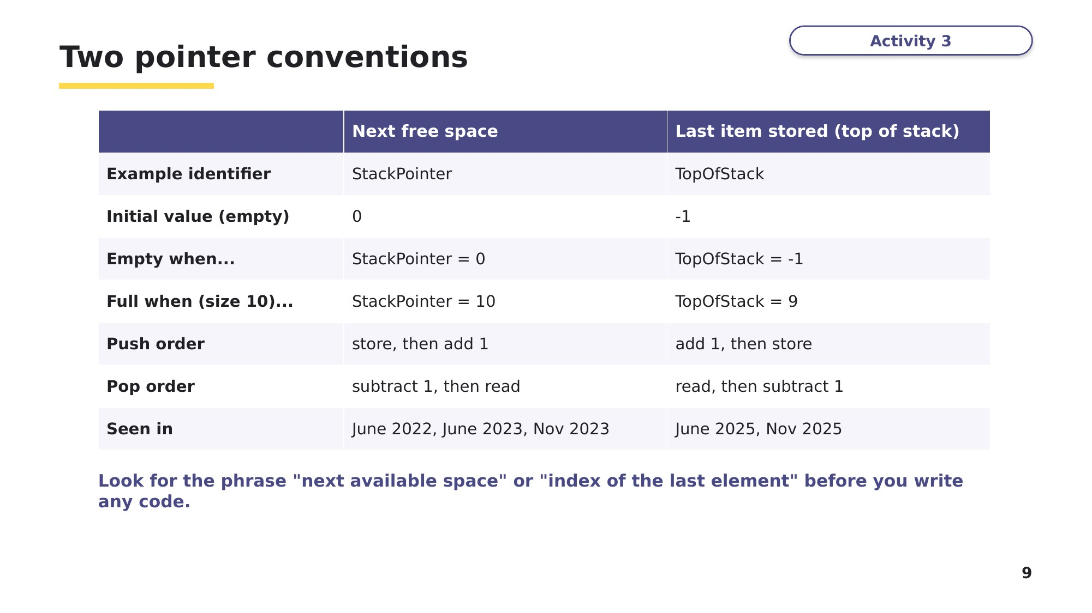
Slide 9 - Two pointer conventions
Task 2 (continued)
Part B - The SAME operations are carried out on a stack that uses TopOfStack instead (the index of the last item stored), initialised to -1. State the value of TopOfStack after the final Pop(), and write the condition that caused Push(7) to be rejected. [2]

Learn Writing Push() and Pop()
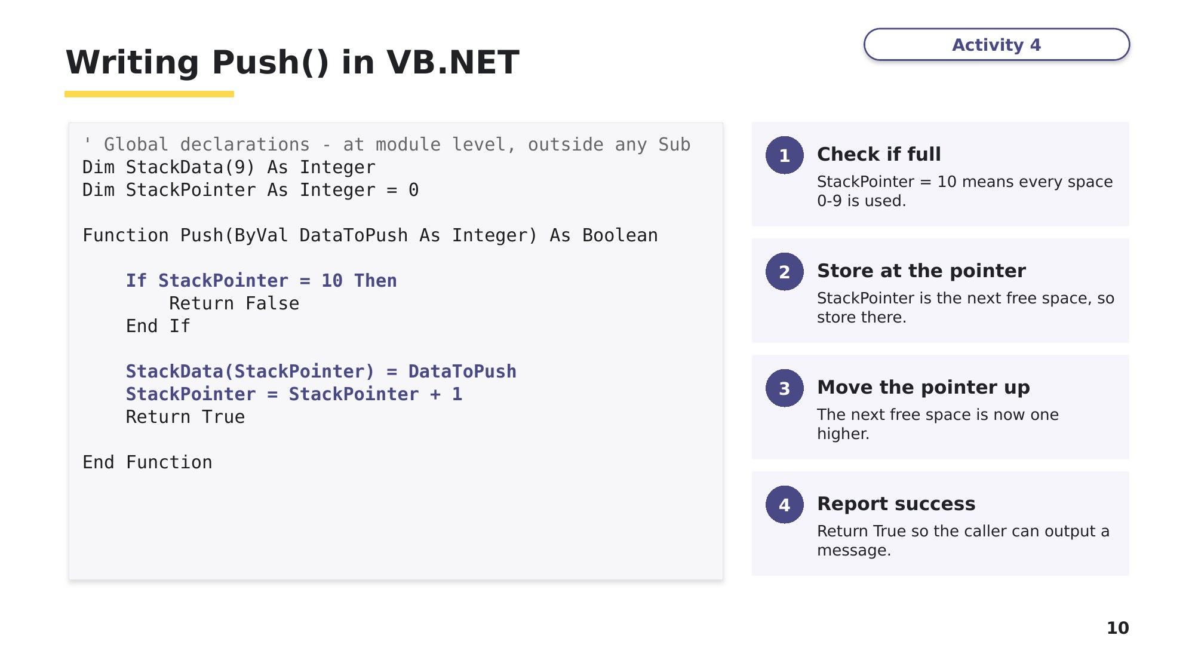
Slide 10 - Writing Push() in VB.NET
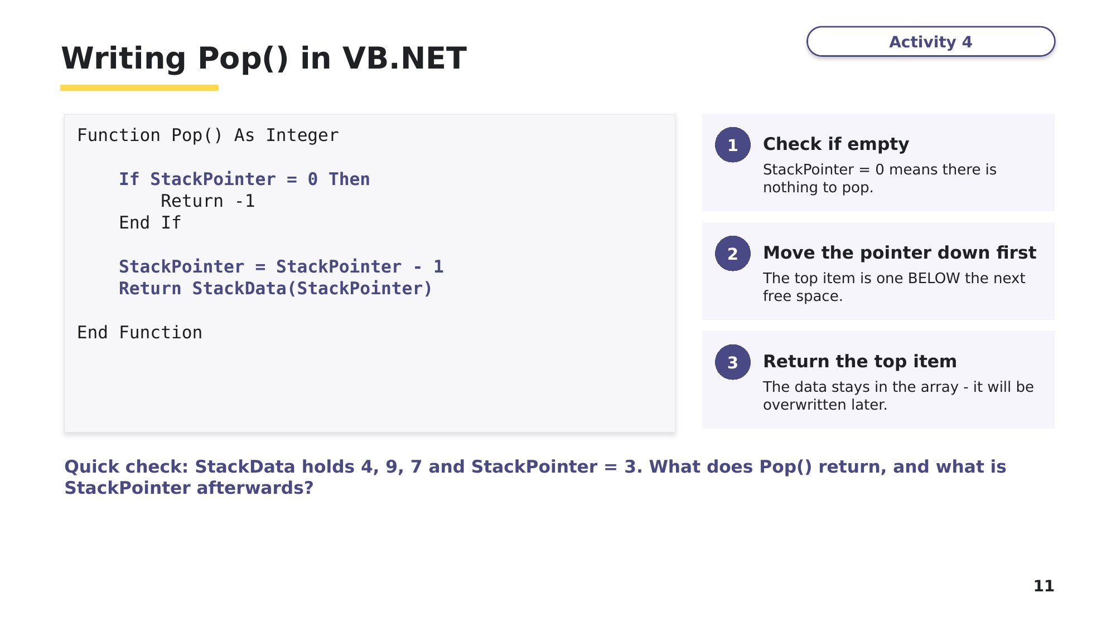
Slide 11 - Writing Pop() in VB.NET
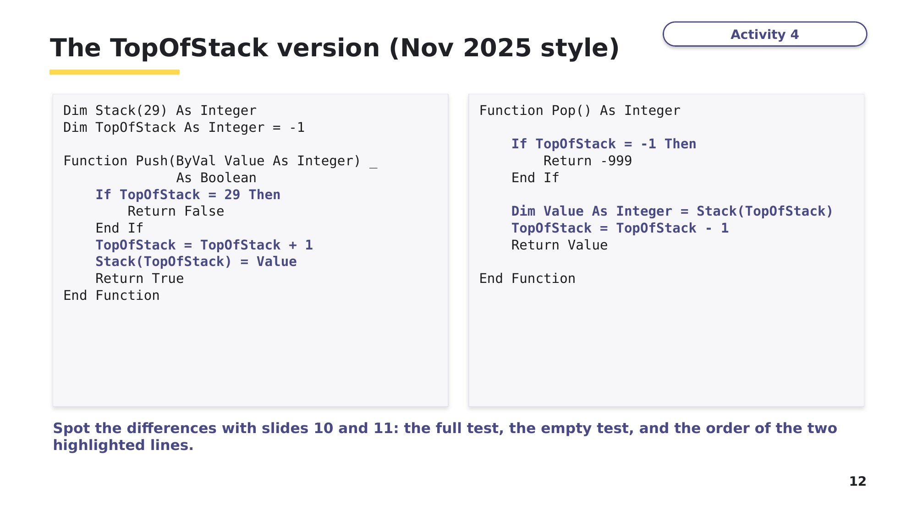
Slide 12 - The TopOfStack version (Nov 2025 style)
Tasks 3 and 4 use the TopOfStack convention from slide 12, but with a different stack size and different return values. Read each specification carefully.
Task 3 Complete the VB.NET code [5 marks]
A stack is stored in the global array Stack, which holds up to 20 strings (indices 0 to 19). The global variable TopOfStack stores the index of the LAST item stored and is initialised to -1.
The function Push() takes a string parameter. It returns -1 if the stack is full, and returns 1 if the item is pushed successfully. There are five gaps, numbered (1) to (5). Write the missing VB.NET code for each gap.
Function Push(ByVal DataToPush As String) As Integer
If TopOfStack = (1)................................ Then
Return (2)................................
End If
TopOfStack = TopOfStack (3)................................
Stack((4)................................) = DataToPush
Return (5)................................
End Function
(1) ______________ (2) ______________ (3) ______________ (4) ______________ (5) ______________
Hint: in this convention, which comes first - moving the pointer or storing the item?
Task 4 Write a function from a specification [4 marks]
This task is written in the same style as a real Cambridge 9618 Paper 4 question (June 2025). Read the specification carefully before you write any code.
Using the same Stack and TopOfStack as Task 3, write program code for a function Pop() that:
- returns the string "-1" if the stack is empty
- if the stack is not empty, returns the item at the top of the stack
- updates TopOfStack.

Task 5 Extension - find and fix the bugs
A student wrote Pop() for a stack of 10 integers where StackPointer holds the next FREE space (the convention used in the lesson, initialised to 0). Pop() should return -1 if the stack is empty. The function contains TWO errors. Identify each error, explain the effect it would have, and write the corrected code.
Function Pop() As Integer
If StackPointer = 10 Then ' <-- line A
Return -1
End If
Dim Item As Integer = StackData(StackPointer) ' <-- line B
StackPointer = StackPointer - 1
Return Item
End Function
Error 1 (line A):

Error 2 (line B):

Learn How you will be marked
Before you build the program in Task 6, read how examiners marked Push() in the real exam. Use it as a checklist for your own code.
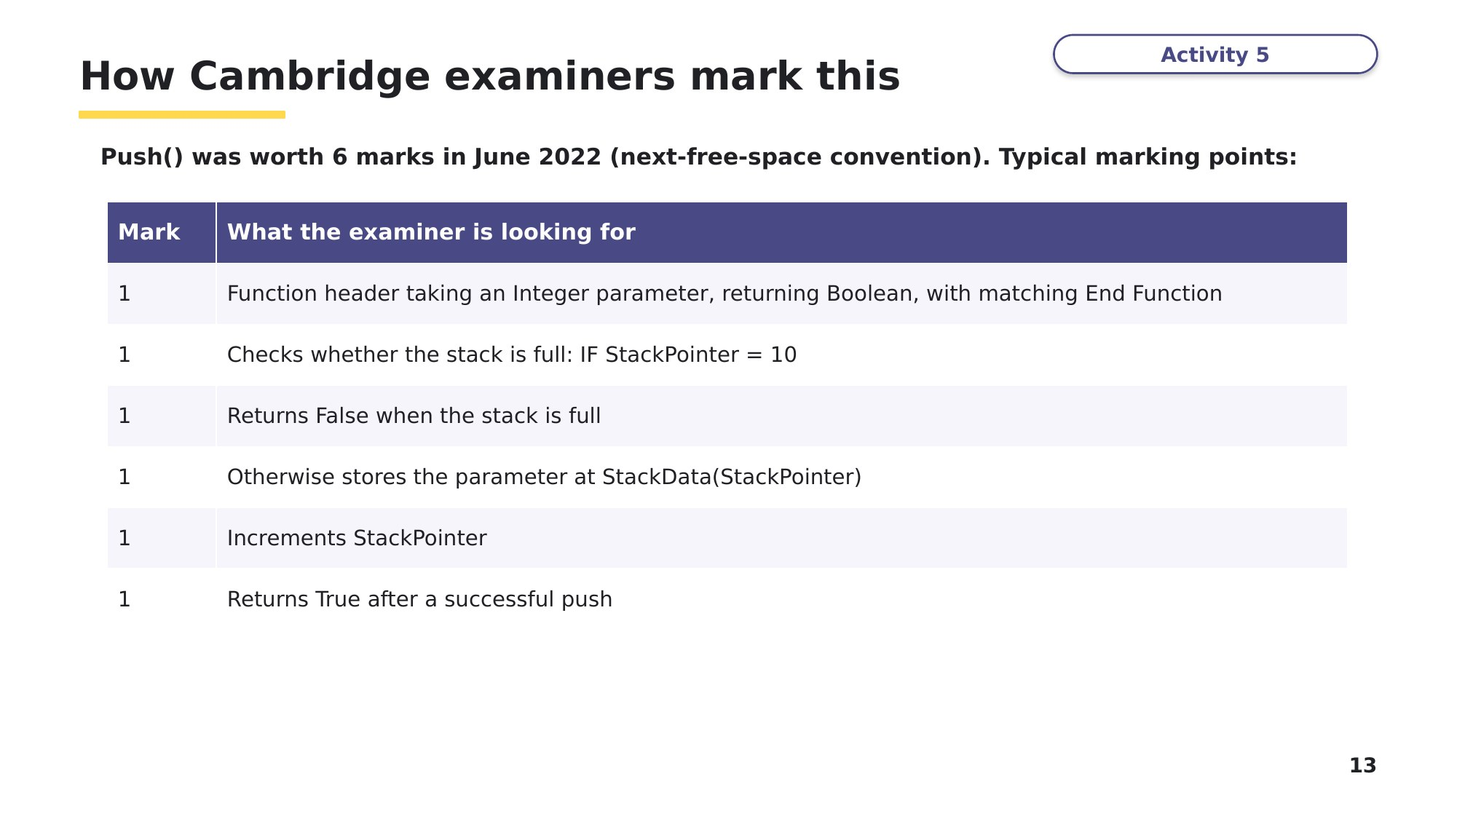
Slide 13 - How Cambridge examiners mark this
Task 6 Build it - at the computer [25 marks]
Based on Cambridge 9618 Paper 4, June 2022, Question 1. Create a new VB.NET console application called Question1_J22. Copy your code and screenshots into an evidence document as you go, exactly as you would in the exam.
A program needs a stack that can store up to 10 integers. A global 1D array StackData stores the stack. The global variable StackPointer points to the next available space in the stack and is initialised to 0.
(a) Write program code to declare the array and the pointer as global data structures. Initialise the pointer to 0. [3]
(b) Write a procedure OutputStack() that outputs all 10 elements in the stack, followed by the value of StackPointer. [3]
(c) The function Push() takes an integer parameter. It returns False if the stack is full. If the stack is not full, it puts the parameter on the stack, updates the pointer and returns True. Write program code for Push() - try to do it without looking back at the slides. [6]
(d)(i) Write the main program so that it: [5]
- allows the user to enter 11 numbers and attempts to push each one onto the stack
- outputs a suitable message when a number is added to the stack
- outputs a suitable message when a number is not added because the stack is full
- outputs the contents of the stack after all 11 numbers have been attempted.
(d)(ii) Test your program with these 11 inputs, and take a screenshot of the output: 11 12 13 14 15 16 17 18 19 20 21 [1]
(e)(i) The function Pop() returns -1 if the stack is empty. Otherwise it returns the item at the top of the stack and updates the pointer. Write program code for Pop(). [5]
(e)(ii) After your code from part (d)(i), add code to remove two items from the stack using Pop(), then output the updated contents of the stack using OutputStack(). [2]
Predict before you run: after the two Pop() calls, what will OutputStack() show at index 8 and index 9, and what will StackPointer be? Explain why.

Now run your program. Take a screenshot of the output. Was your prediction right?
Stretch (Nov 2025 style)
Write a procedure FindValues() that pops each integer from the stack until the stack is empty, then outputs the largest and the smallest numbers that were in the stack, each with a suitable message. Call it at the end of your main program and test it.

Learn Review
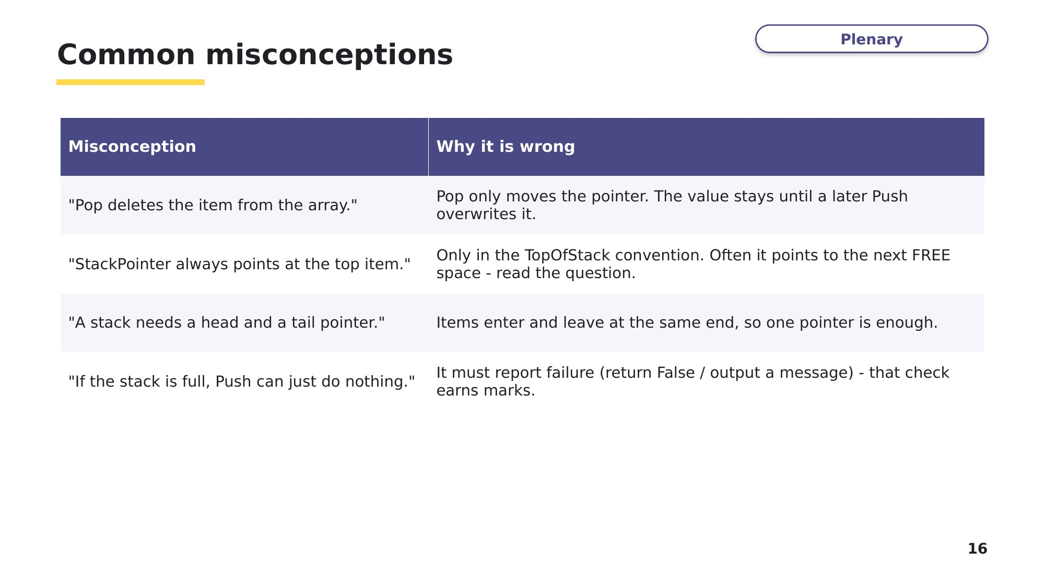
Slide 16 - Common misconceptions
Look back at your Task 1 answers. Correct any you got wrong, using what you have learned.
Exit question
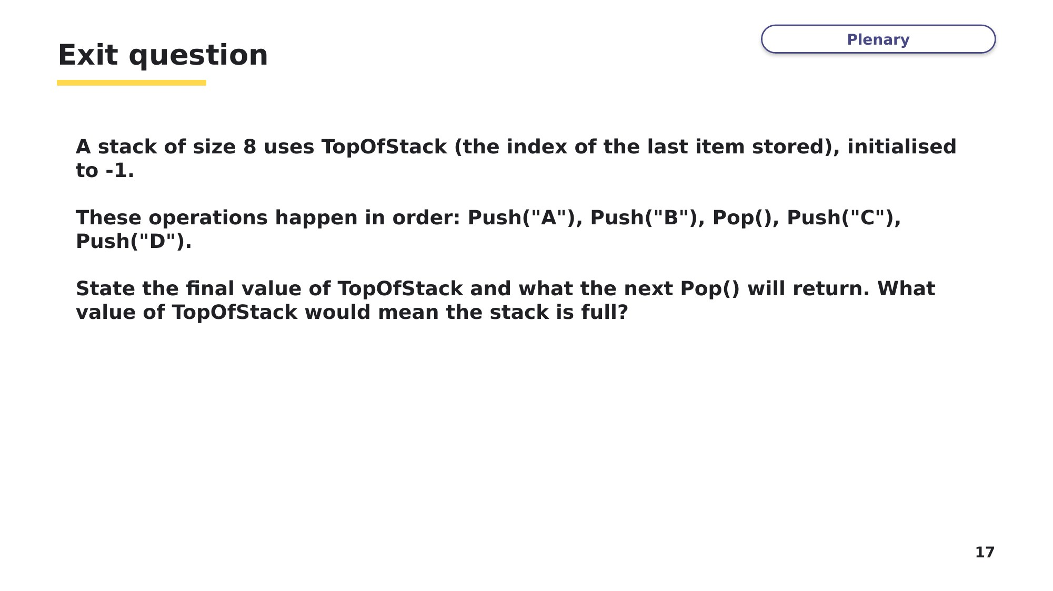
Slide 17 - Exit question

